**Assignment 8**

**TCOD01**

mysql> create database d1

-> ;

Query OK, 1 row affected (0.01 sec)

mysql> use d1

Database changed

mysql> create table library(bookid int,bookname varchar(20),price int);

Query OK, 0 rows affected (0.04 sec)

mysql> create table lib_audit2(bookid int,bookname varchar(20),price int);

Query OK, 0 rows affected (0.03 sec)

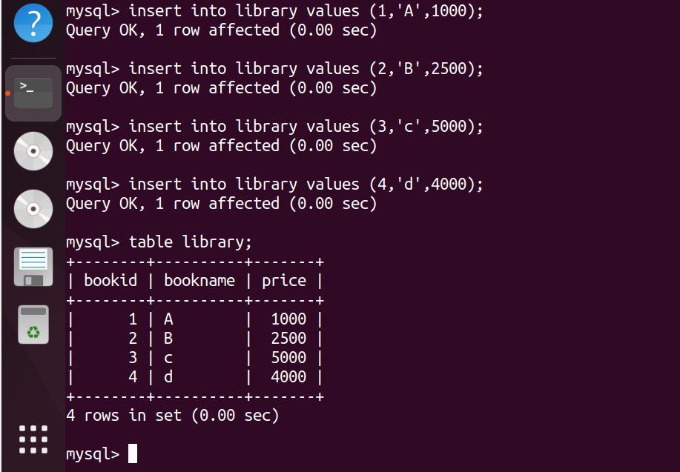

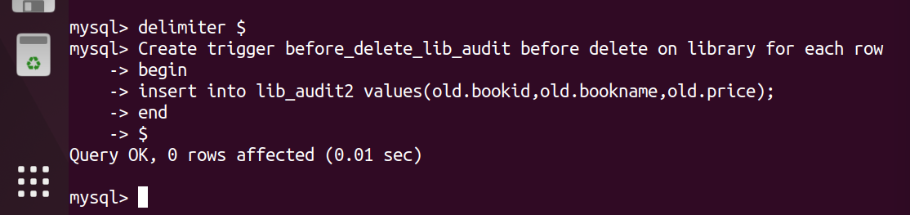

mysql> delete from library where bookid=1 $

Query OK, 1 row affected (0.01 sec)

mysql> delete from library where bookid=4 $

Query OK, 1 row affected (0.01 sec)

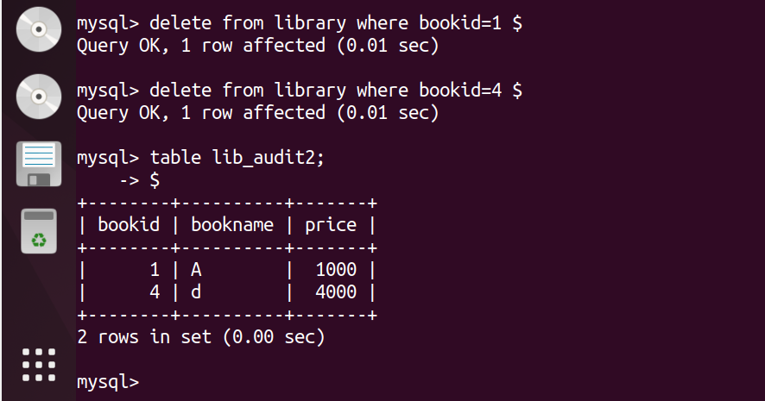

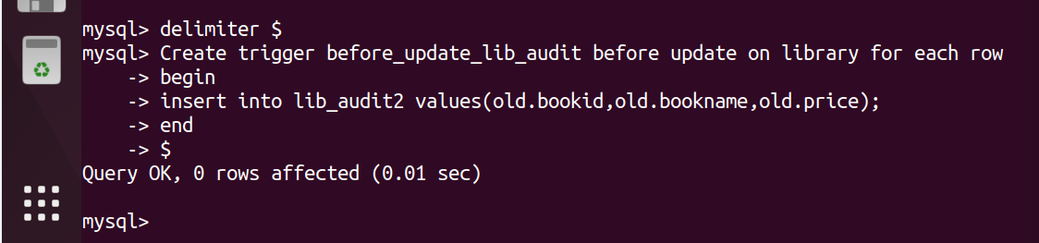

mysql> update library set bookname='ABC' where bookid=2 $

Query OK, 1 row affected (0.01 sec)

Rows matched: 1 Changed: 1 Warnings: 0

